Personal, Social and Emotional development
We will be learning to:
- Be confident in our new surroundings
- Talk about what makes us special
- Think about our special people
- Learn about different feelings and different ways to manage them
Communication, Language and Literacy
Our key texts:
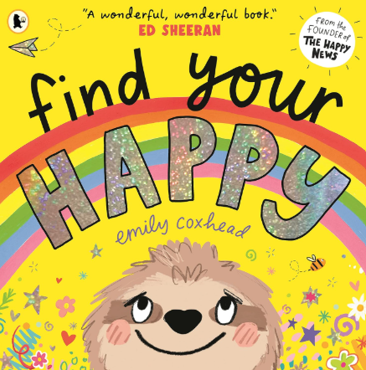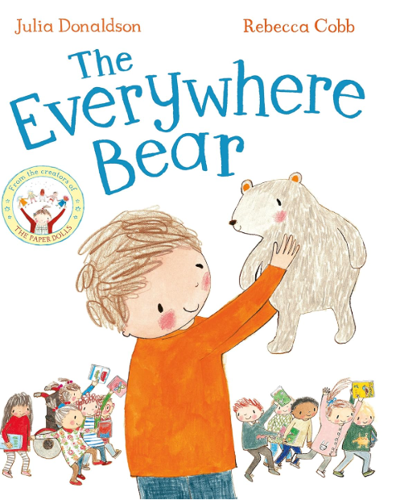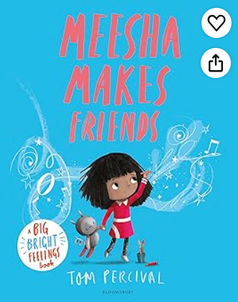
We will be learning to:
- Talk confidently about ourselves and our families and what makes us happy
- Listen to and sequence familiar stories
- Talk, draw and write about our friends

Expressive arts and Design
We will be learning to:
- Use different materials to create
- Draw a self-portrait using art pencils
- Learn the names of different untuned instruments and how they can be played
- Learn how to make long and short sounds
- Use the instruments to add sound effects to the story of Rosie’s walk by Pat Hutchins

Physical Development
We will be learning to:
- Move in a ‘high’ and ‘low’ way
- Make ‘high’ and ‘low’ shapes
- Move in different ways on the apparatus (over, under, around, on, along)
- Use different PE equipment safely, share and learn how to use our imaginations as we play
- To hold a pencil correctly and begin to form the letters we have learned

Mathematics
We will be learning to:
- Sort and match different objects into groups
- Compare amounts- more and less
- Compare objects by size, length, mass and capacity
- Explore, copy and create simple patterns
- Develop our counting and subitising skills to 3
- Find different ways to represent numbers 1,2 and 3
- Find 1 more and 1 less to 3
- Explore the composition of 1,2 and 3

Understanding of the world
We will be learning to:
- Name our body parts and explore what our bodies can do
- Name and investigate the 5 senses
- Explore our surroundings to find out about Autumn
- Talk about what makes us special and what we can do
- Name and describe people who are special to us
- Explore our new school and go on different journeys around it
- Find our favourite and least favourite places in school and explain why
- Use the pen on the interactive board to click, drag and drop as we explore Purple Mash

All about me!
Year R Curriculum Overview
Autumn 1 - 2026

Important messages
Please make sure that your child has a pair of named welly boots and a waterproof coat ready for outdoor play every day and forest school.
Parents are invited to meet us at the church on 21st October at 10am for our Harvest service.

Religious Education
We will be learning to:
- Think and share our thoughts about God
- Listen to and sequence The Creation story
- Explore why God is important to Christians
- Understand and celebrate a Harvest festival

