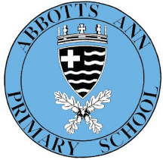
Enquiry question: How does Earth move or change and what is beyond?

English
Unit 1: Pandora Discovered
Outcome: non-chronological report on an imaginary planet
Unit 2: Cosmic
Outcome: narrative that entertains with a focus on characterisation
Unit 3: Ode to the Himalayas
Outcome: Poems



Y1/2 Curriculum Overview
Autumn 1 (Cycle B)
RE
What does peace mean to Buddhists?
We will be exploring the concept of peace and how this creates a sense of belonging to the Buddhist faith.
Maths
Place value
Y5: Numbers to one million
Y6: Numbers to ten million
Addition and Subtraction, Properties of numbers


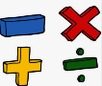
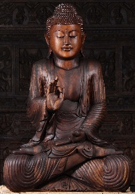
Enquiry-Led Learning
To answer our enquiry question we will be getting hands-on, delving into 3 different subjects: science, geography and Art. We will start by being scientist and looking at our Earth and Beyond, including learning about the shape of the earth, movement of Earth, moon and other planets, as well as day and night. In Geography, we will discover how mountains are formed and explore mountain features and formation with a focus on the Himalayas. As artists, we will be drawing and using mixed media skills to create space landscapes.

Important Dates
28th September INSET
Harvest Festival 21st October 10am at the church. Parents are welcome to meet us at the church.

Homework
- Reading – 3x week = 1 HP, 5x week = a raffle ticket
- Spellings – tested each Wednesday; homework sheet given out on Fridays
- Y6 CGP English and Maths collected each Wednesday; given out on Fridays.
- TT Rockstars, Spelling Shed and BBC Bitesize are great places for extra practice too
PE will take place on a Thursday (Rugby PH Sports) and Friday (Gymnastics with Miss Bulkeley). In PSHE we will be learning about Me and my Relationships. In French we will be learning (Je me présente) introducing myself. Listen to Me lessons from Hampshire Music Services (Brass) will be visiting to teach us for our music lessons. Finally, in Computing we will be data detectives: filtering and sorting, entering data, graphing and information requests

