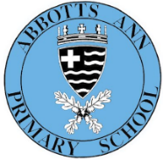
Enquiry question: How do different biomes help living things to survive?
English
Unit 1: Text driver: We Travel So Far
by Laura Knowles
Outcome: to create a class book about migrating animals
Unit 2: Text driver: Interview with a Kangaroo by by Andrew Seed
Outcome: An interview with an animal from a particular biome

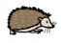
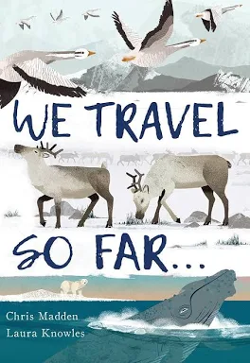
Y3/4 Curriculum Overview
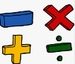
Autumn 1 (Cycle B)
Important Dates
Harvest Festival 21st October 10am at the church. Parents are welcome to meet us at the church.

Homework
Reading – 3x week = 1 HP, 5x week = entry into the weekly draw
Spellings – given out on a Wednesday for the following Wednesday- 1x a week= 2 HP, 2x a week= 4 HP, 3x a week = 10HP
TTRS- as often as possible!
Times tables on Purple Mash
PE will take place on a Wednesday (with Mrs Readman-Netball) and Tuesday (Miss Crawely- football).
As musicians, we will be singing together and exploring songs through the community.
During PSHE, we will be learning how to recognise and manage our relationships with friends.
In computing, we will create animation through 2animate.
Maths
We will be starting our learning as mathematicians by looking at place value. Year 3 will be working with numbers within 1000 and Year 4 will be working with numbers within 10,000
For the latter half of the term, we will be learning about addition and subtraction, using a range of strategies to solve calculations and problems.
RE
Our RE question this term is: ‘What kind of world did Jesus want?’
We will be exploring the concept of ‘neighbour’ and what it means to be a good neighbour.
Enquiry-Led Learning
To answer our enquiry question we will be getting hands-on, delving into 3 different subjects: geography, science and Art. In Art, we will be exploring Henri Rousseau's painting ‘Tiger in a Tropical Storm’. We will be using the same style to create our own tropical rainforest pictures. In Geography, we will focus on biomes around the world, looking at different types of biomes and the animals that live there. We will then focus on the biome of the rainforest in Peru. We will then become scientists and explore living things and their habitats. We will be looking at animal classification and groups, learning how different animals adapt to their habitats.

